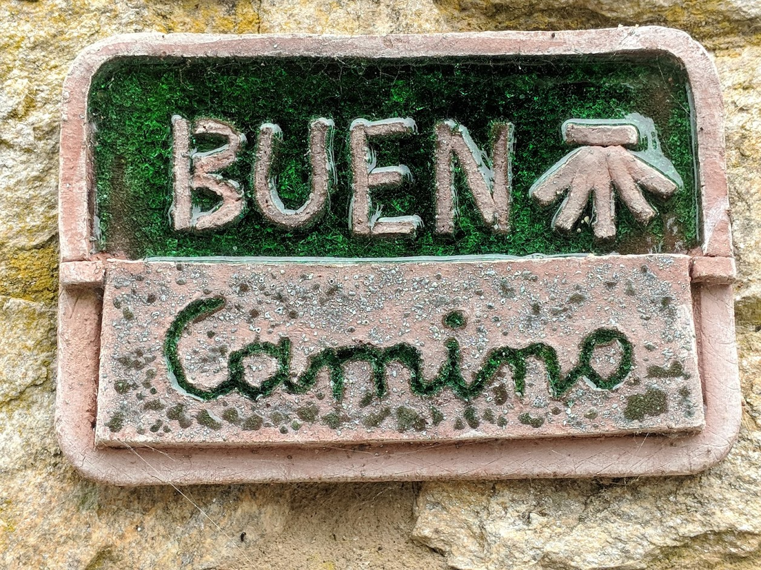

Virtual Pilgrimage – El Camino
“If you want to go quickly, go alone. If you want to go far, go together.” African Saying

Each Day:
Morning Prayer

Guardian of my soul,
guide me on my way this day,
Keep me safe from harm.
Deepen my relationship with you,
your Earth, and all your family.
Strengthen your love within me
that I may be a presence of your peace in our world.
Amen.

- Tom Pfeffer and Joyce Rupp from Walking in a Relaxed Manner

Walking/Practice

Reflection and Journaling

Evening Prayer

Bless me this night, O God, and those who I know and love. Bless me this night, O God, and those with whom I am not at peace. Bless me this night, O God, and every human family. Bless us this night, O God, that we may be set free to love. Amen.

- John Philip Newell, Sounds of the Eternal

Gatherings:

January 24, 2021 –Pilgrimage, Group Covenant, Finding our Way
Traveler a poem by David Whyte
January 31, 2021 – Control
Camino a poem by David Whyte
February 7, 2021 – Letting Go(d)
Santiago a poem by David Whyte
February 14, 2021 – Gift and Growth
Finisterre a poem by David Whyte

Gathering Reflection and Prayer
Sharing:
Practice the art of attention and listening – what did you see and hear today?
Practice the art of renewing yourself each day – what refreshed you today in heart, mind, body or soul?
Practice the art of meandering toward the center of every place – what drew you in today?
Practice the ritual of reading sacred texts – in what ways did you encounter the Holy today?
Practice gratitude and praise singing – for what and whom are you grateful today?
I wonder, what continues to unfold in you?
What fills you with awe today?

Summit Avenue Pilgrimage Walks:
11:00 AM
January 27, 2021 Meet at HOH
February 3, 2021 Meet at HOH
February 10, 2021 Meet at the Kowalski’s Parking Lot
February 17, 2021 Meet place TBD

Pilgrim Credo from Murry Budo
I am not in control.
I am not in a hurry.
I walk in faith and hope.
I greet everyone with peace.
I bring back only what God gives me.

Elements of Pilgrimage
Desire
What is it that you want? What are your hopes? What do you remember, claim and re-claim?
Motivation
What is the motivation for your pilgrimage? Giving thanks? Grief or guilt? Re-thinking the direction of your life? Explore new territories? Strengthening your spirituality?
Sense of Timing
Is this emotionally, intellectually, psychologically, spiritually time for a new perspective?
Surrender: Letting Go
Let go of expectations. “Trust that everything will (eventually) turn out for the best. . . . Believe in the power of Love who wants the best for me and will lead me in the right direction.”
Synchronicity
Rest in the design “greater than my own.”
Ritual
Communal pattern of our days, journaling, prayer, or new spiritual practice?
Sharing Stories and Celebrating

Writing Prompts

What are the places that bring me alive?
What do I want?
What will come through? Will I bring my fears, face my fears by coming through?
Ce leis thir? What is central?
Where do I breathe? Where are my breathing holes?
If I turn my ear inward and listen to a whispered truth within, what I hear on this day …
Not everything is lost ….
I’m saving up for …
It’s a chance to get …
And Justice listened when I said …
What if love ….
If I had more time for love …
Traveling through the land of love, I have known …
If I stay ….
I feel my heart harden when …
Prayer is …
A heavy stone of judgment I carry is …
Bowing my head to listen, I hear (or heard) …
What I do not know ….
The story of my faith is telling me …
While I wait …

Week 1: Finding Our Way
Each Day:
Morning Prayer
Guardian of my soul,
guide me on my way this day,
Keep me safe from harm.
Deepen my relationship with you,
your Earth, and all your family.
Strengthen your love within me
that I may be a presence of your peace in our world.
Amen.
- Tom Pfeffer and Joyce Rupp from Walking in a Relaxed Manner

Walking/Practice

Reflection and Journaling

Evening Prayer

Bless me this night, O God, and those who I know and love. Bless me this night, O God, and those with whom I am not at peace. Bless me this night, O God, and every human family. Bless us this night, O God, that we may be set free to love. Amen.

- John Philip Newell, Sounds of the Eternal

From Joyce Rupp
“To be a pilgrim is to be willing to live with the mystery of what will happen both interiorly and exteriorly as one walks day after day after day toward the destination of the sacred site. What happens inside cannot be planned or mapped out in the same way that the physical is mapped. Becoming a pilgrim means that there are not maps of the heart. One simply holds the hand of the Great Pilgrim and travels with hope that one day the spiritual benefits of the road will reveal themselves and be understood.” (40).

Week Two: Control
Each Day:
Morning Prayer
Guardian of my soul,
guide me on my way this day,
Keep me safe from harm.
Deepen my relationship with you,
your Earth, and all your family.
Strengthen your love within me
that I may be a presence of your peace in our world.
Amen.
- Tom Pfeffer and Joyce Rupp from Walking in a Relaxed Manner

Walking/Practice

Reflection and Journaling

Evening Prayer
Bless me this night, O God, and those who I know and love. Bless me this night, O God, and those with whom I am not at peace. Bless me this night, O God, and every human family. Bless us this night, O God, that we may be set free to love. Amen.

- John Philip Newell, Sounds of the Eternal

From Joyce Rupp
“I had to let go of trying to control and have everything go the way I wanted it to go. I needed to look at how I did my life, not so much what I did with my life. The Camino reminded me that life is always going to have both ups and downs. I need to accept this as a natural process of growth and stop trying so hard to make it go my way.” (23).

Week Three: Security and Letting Go(d)
Each Day:
Morning Prayer
Guardian of my soul,
guide me on my way this day,
Keep me safe from harm.
Deepen my relationship with you,
your Earth, and all your family.
Strengthen your love within me
that I may be a presence of your peace in our world.
Amen.

- Tom Pfeffer and Joyce Rupp from Walking in a Relaxed Manner

Walking/Practice
Reflection and Journaling

Evening Prayer
Bless me this night, O God, and those who I know and love. Bless me this night, O God, and those with whom I am not at peace. Bless me this night, O God, and every human family. Bless us this night, O God, that we may be set free to love. Amen.

- John Philip Newell, Sounds of the Eternal

From Joyce Rupp
“It took just one day on the Camino to understand that I had barely begun the process of letting go."”(61)
“The Camino constantly told us, ‘Enjoy what you have now but do not hang on to it’.” (65)

From Helen Keller
“Security is mostly superstition. It does not exist in nature, nor do the children of humankind as a whole experience it. Avoiding danger is no safer in the long run than outright exposure. Life is either a daring adventure, or it is nothing at all.”

Joyce Rupp
Walk in a Relaxed Manner: Life Lessons from the El Camino

David Whyte (DW)
Consolations: The Solace, Nourishment and Underlying Meaning of Everyday Words
Crossing the Unknown Sea: Work as a Pilgrimage of Identity
The Heart Aroused: Poetry and the Preservation of the Soul in Corporate American
The Three Marriages: Reimagining Work, Self and Relationship
Whyte’s Poetry
The Bell and the Blackbird
Everything is Waiting for You
The House of Belonging
Pilgrim
River Flow: New and Selected Poems
The Sea in You: Twenty Poems of Requited and Unrequited Love

Pilgrim Blessing
By Macrina Wiederkehr

May the flowers spring up where your feet touch the earth.
May the feet that walked before you bless your every step.
May the weather that’s important be the weather of your heart.
May all your intentions find their way into the heart of God.
May your prayers be like flowers strewn for other pilgrims.
May your heart find meaning in the unexpected events.
May friends who are praying for you be carried in your heart.
May the circle of life encircle you along the way.
May the broken world ride on your shoulders.
May you carry your joy and your grief in the backpack of your soul.
May you remember all the circles of prayer throughout the world.

